Panel Creation Manual

Contents

1. Setting The Database Path 3

1.1 Notes 3

1.2 Directions 3

2. Creating A New Panel Outline 5

1. Enter A Part Number 5

2. Grid Size 6

3. Choose an Image 6

4. Add Layers 8

5. Placing images 9

6. Resetting the Images 10

7. Adding the Panel Creation to the Database 11

# Setting The Database Path

## Notes

* Setting the database path will create a new database if one does not exist already
* If you choose a path that has a database already, it will not be over written
* To delete a database, you must do it via the file explorer

## Selecting the Database Directory

1. A screenshot of a computer

   Description automatically generatedIn the tear off menu in the upper left corner, select the settings option
2. Click the settings button

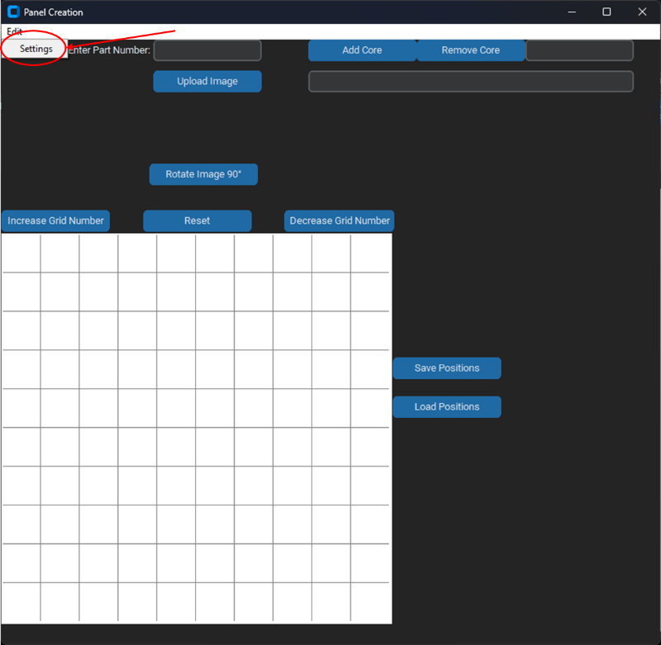

1. 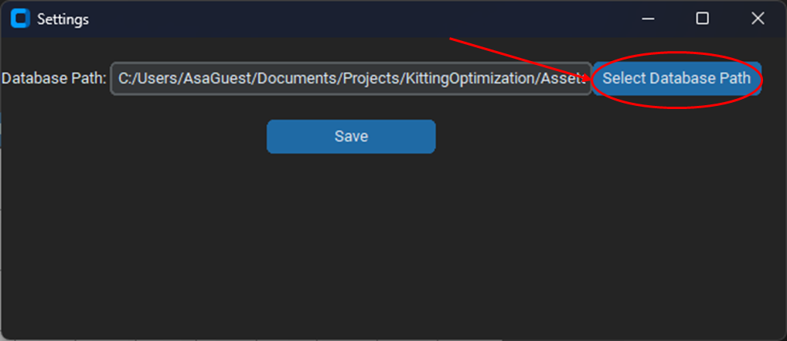A new page will appear, and press database path
2. A file explorer will pop up. Select the desired path you would like the database to be stored in or the path that one exists in

# Creating A New Panel Outline

## Enter A Part Number

1. 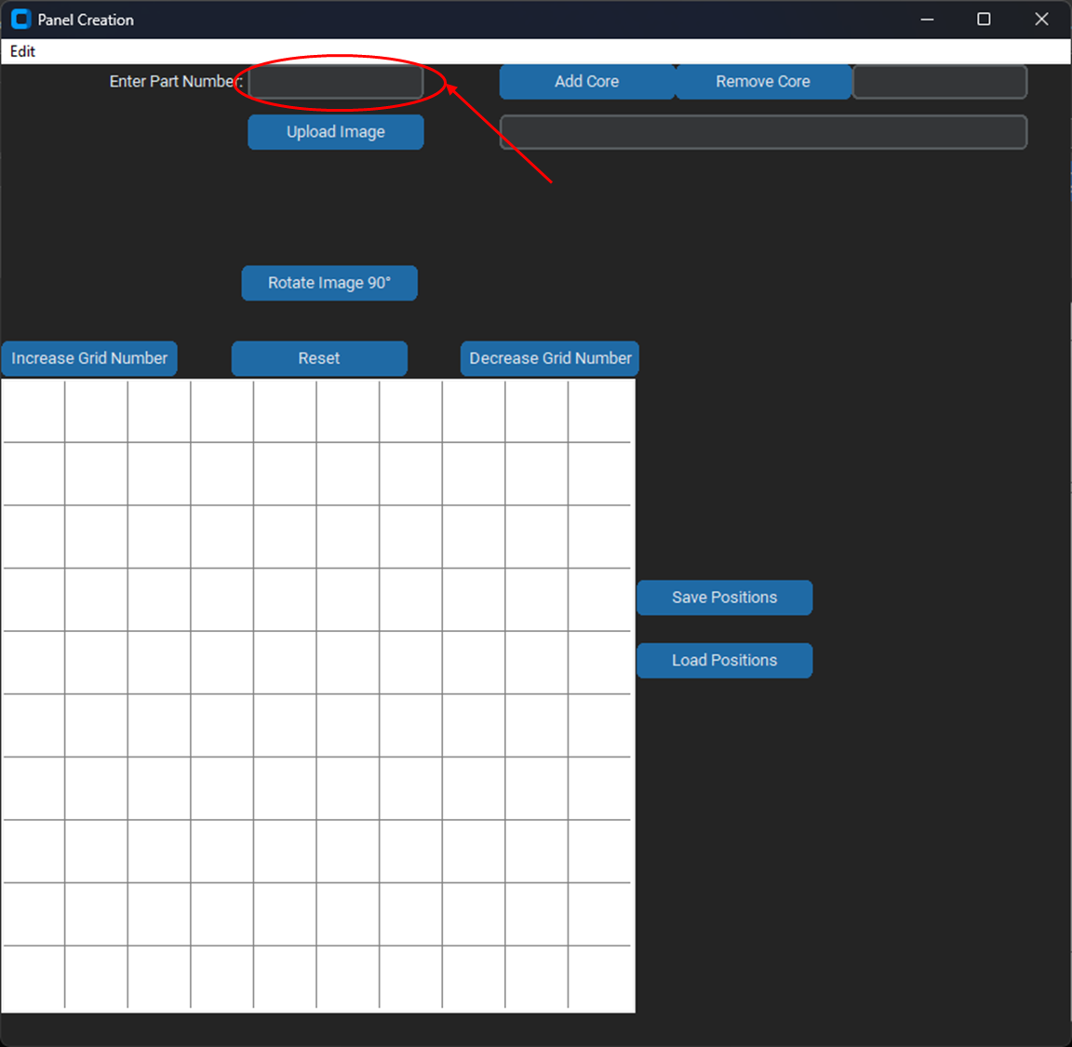Enter a part number in the Part Number Entry Box

## Grid Size

1. 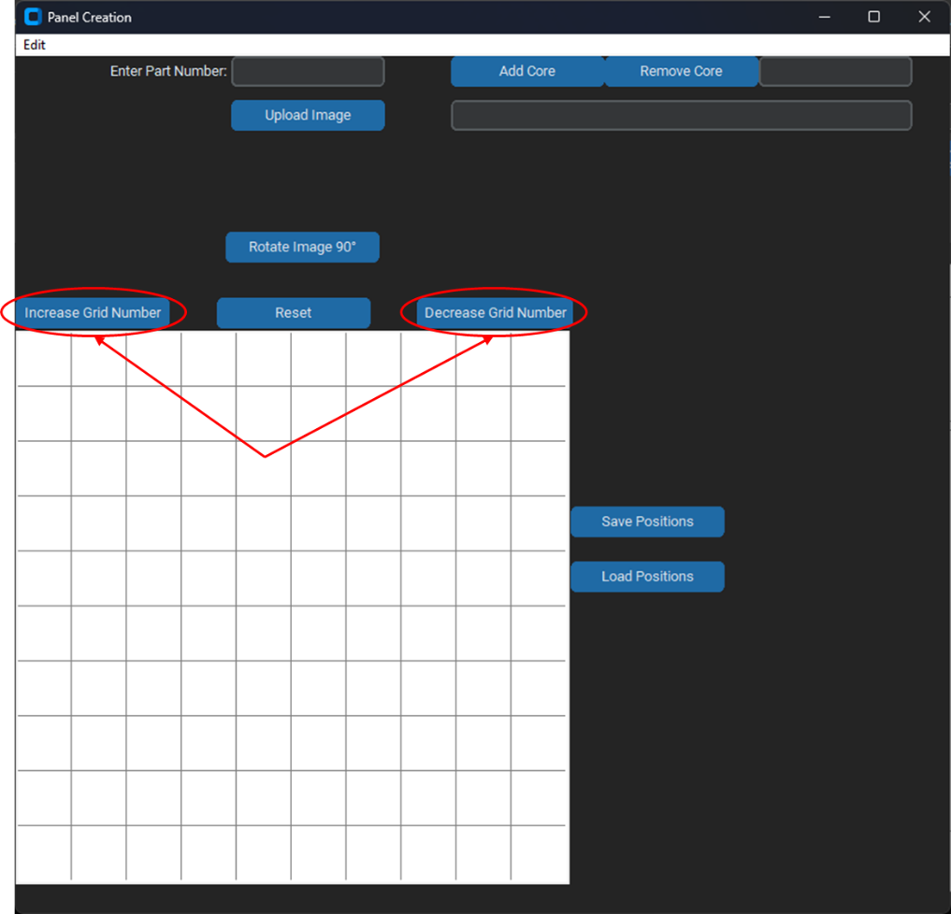Using the “Increase Grid Number” and “Decrease Grid Number” buttons, set the grid size to fit all parts on a panel
2. Once an image is selected, these buttons will become disabled

## Choose an Image

1. Press Upload Image button
   1. 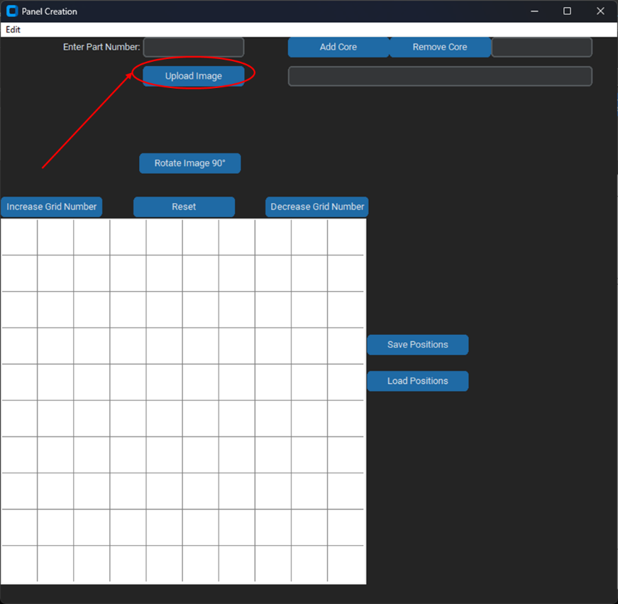A file dialog will appear, choose an image that represents the outline of the part
2. The grid buttons “Increase Grid Number” and “Decrease Grid Number” are now disabled

## Add Layers

Be sure that all core names are entered in order from the top to the bottom layer

1. 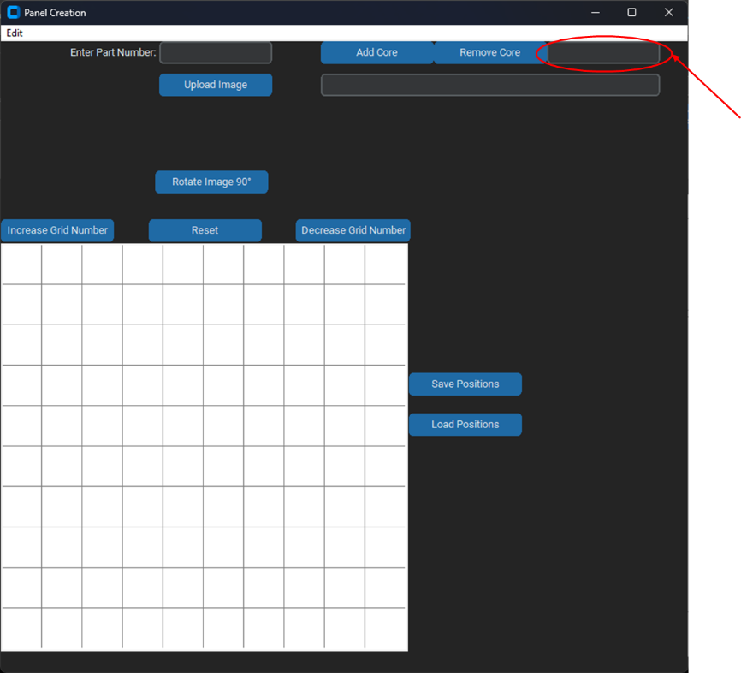In the upper right entry box, enter the name of a core.
2. 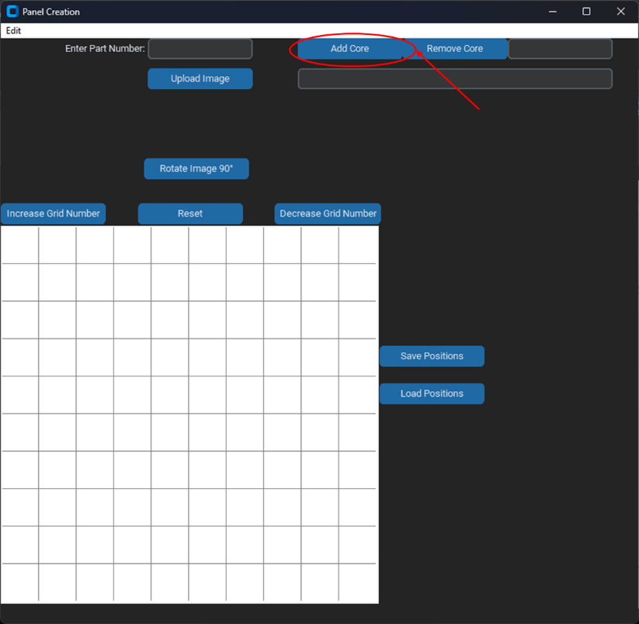Press the add core button
3. Repeat until all core names are added
4. 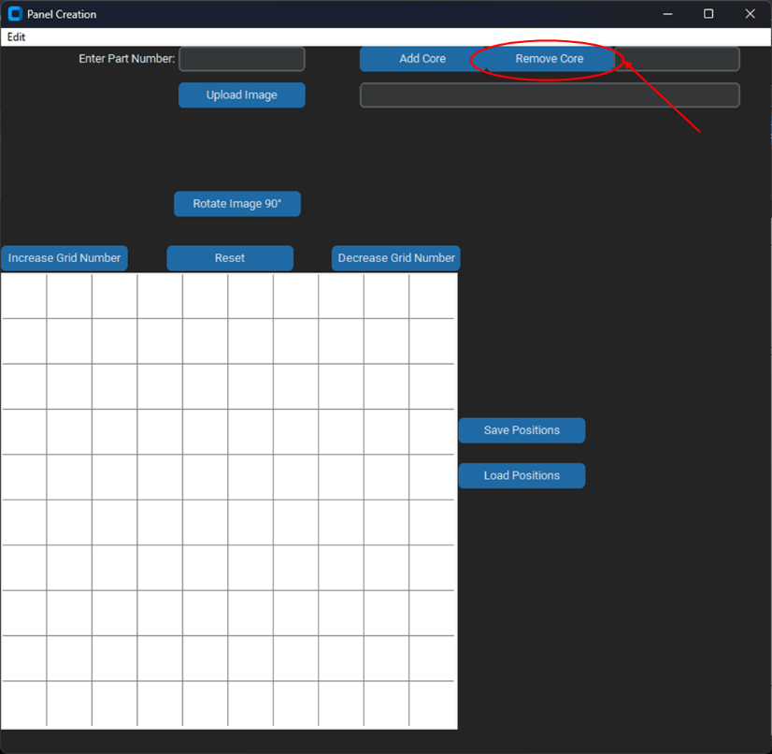If a core needs to be removed, press the remove core button. This will remove the most recently entered Core

## Placing images

1. Click in the grid region where the image would appear on the panel
2. If an image is accidentally placed, click the image once more
   1. Make sure the mouse has moved slightly from the original click location to remove the image

## Resetting the Images

1. To change the grid size, and remove the image, press the reset button directly above the center of the grid

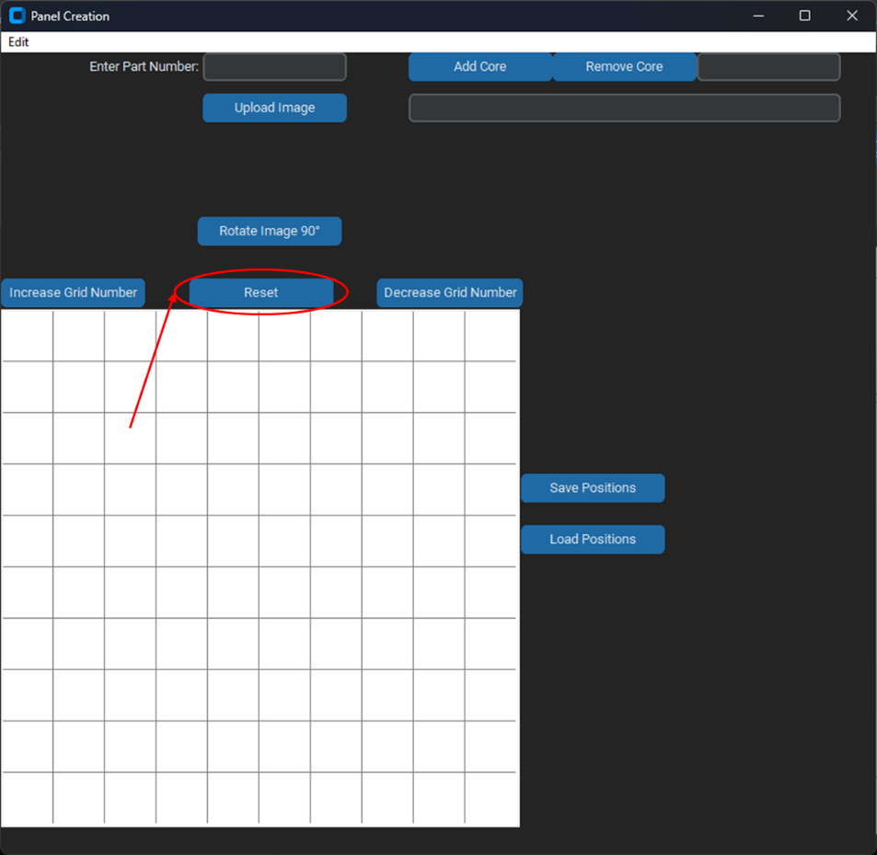

## Adding the Panel Creation to the Database

Once the panel is created and added to the database, it can only be removed by someone with direct access to the database

1. Ensure all fields (Part Number, Core Names, Grid Layout) are filled and correct
2. 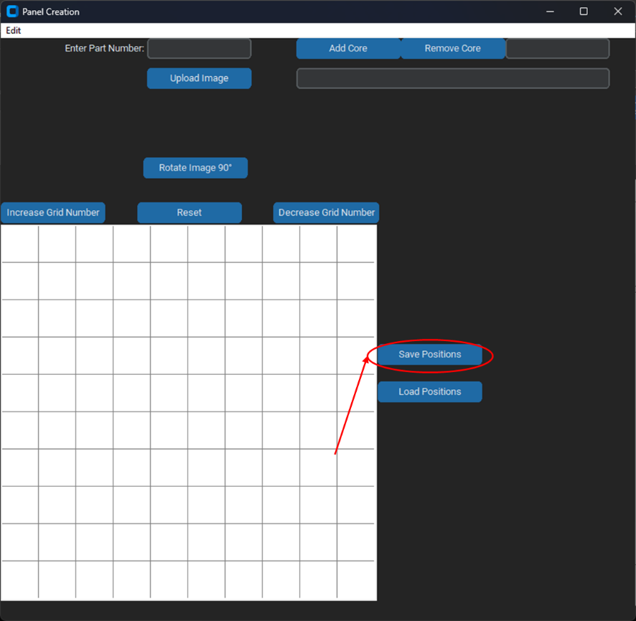Press the Save Positions button
3. A file dialog will appear, select the save folder